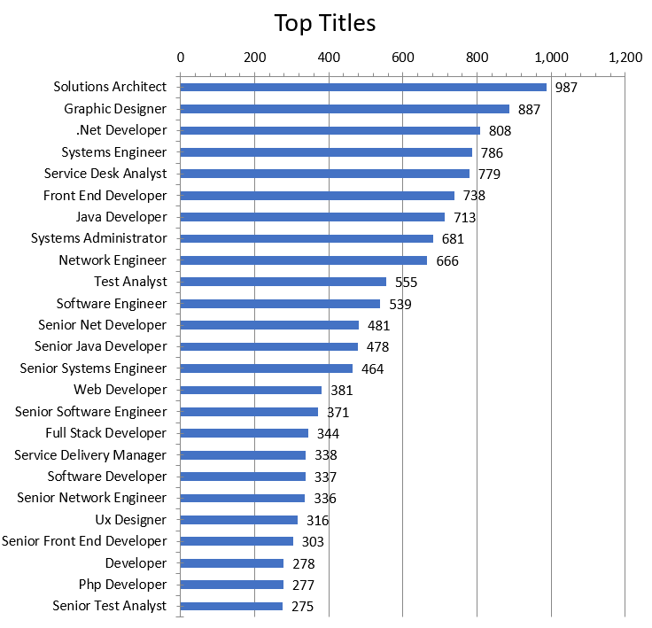**Figure 1:** Labour Insight Jobs (Burning Glass Technologies), Mar. 24, 2017 - Mar. 23, 2018

|  |  |  |
| --- | --- | --- |
| **Name** | **Job Title** | **Demand (Job Postings)** |
| Artem | Network Engineer | 666 |
| Victor | UX Designer | 316 |
| George | Systems Analyst | 221 |
| Anthony | Senior Software Developer | 178 |
| Sahil | Security Analyst | 173 |

By looking at the job titles for each group member, it is made clear that Artem’s ideal job is very much in high demand most likely because this is the one field where a lot of innovation and development is shown as the demand for the world’s population to stay connected is high. Other than that, everyone else’s job titles are fairly similar in demand with Victor’s ideal job as a UX Designer being the highest in demand out of the rest. The fact that UX is up there in demand shows that user experience is very important in day-to-day life and overall developing a good user interface in many different IT applications is important to people.

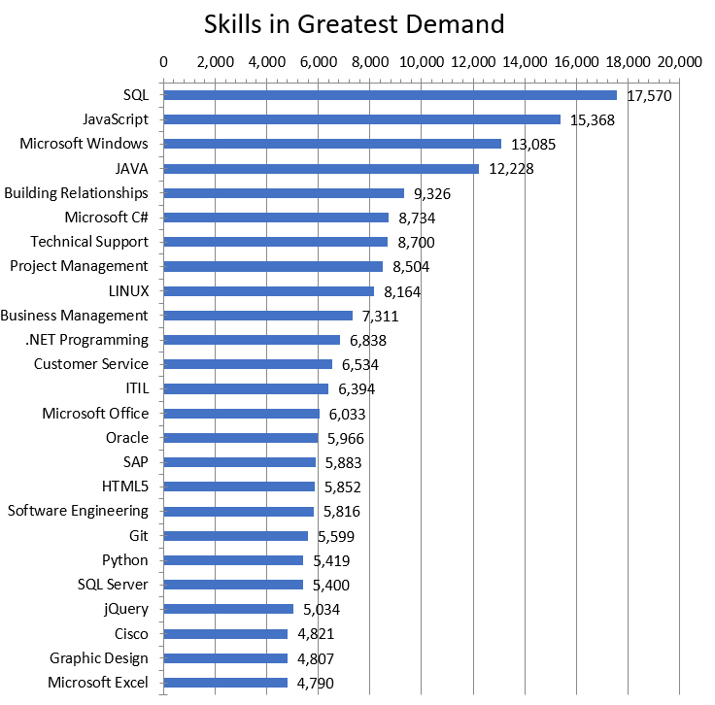**Figure 2:** Labour Insight Jobs (Burning Glass Technologies), Mar. 01, 2017 - Feb. 28, 2018

|  |  |
| --- | --- |
| **IT Specific Skills** | **Demand (Job Postings)** |
| SQL | 3,570 |
| Java | 2,860 |
| Microsoft Windows | 2,699 |
| Python | 1,150 |
| Network Engineering | 880 |
| Firewalls | 707 |
| IT Support | 641 |
| Information Security | 542 |
| Systems Analysis | 453 |
| Web Applications | 305 |

By further inspecting the IT specific skills required for the entire group, it is pretty safe to say that programming languages such as SQL, Java and Python are a must have in order to be considered above the average worker. The demand in the understanding of various programming languages nowadays is quite high so to have these skills on hand is a positive towards achieving a future career. Of course, the need to understand how to use Microsoft Windows and navigate around the operating system is definitely required for pretty much all IT related jobs. The rest of the IT specific skills are fairly similar in terms of demand as they are more focused within certain areas of IT with network engineering being at the top of them which definitely makes sense as the job title of network engineer itself is fairly high in terms of demand.

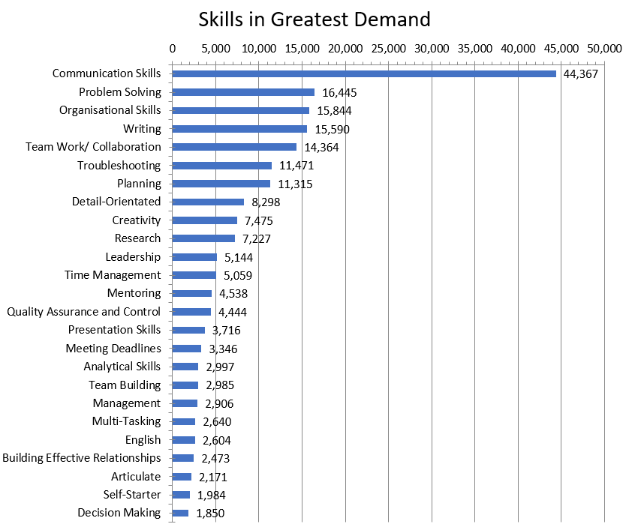**Figure 3:** Labour Insight Jobs (Burning Glass Technologies). Mar. 01, 2017 - Feb. 28, 2018

|  |  |
| --- | --- |
| **General Skills** | **Demand (Job Postings)** |
| Communication skills | 44,367 |
| Problem solving | 16,445 |
| Writing | 15,590 |
| Teamwork/Collaboration | 14,364 |
| Troubleshooting | 11,471 |
| Analytical skills | 2,997 |
| Decision making | 1,850 |
| Critical thinking | 437 |

By overwhelming numbers, the demand for communication skills as a general skill is very much sought out for. From an IT standpoint, to be able to solve an issue or devise a solution, you need to be able to communicate your ideas clearly to others. By communicating clearly, you are able to avoid confusion and possible frustration with other team members or customers. It is also granted that you are able to solve problems efficiently and effectively to reach the intended goal and this is also in high demand. To be able to collaborate well and troubleshoot issues also go hand in hand as most IT jobs will require you to work with a team and be able to troubleshoot problems that may occur.

**Top 3 highest skills**

|  |  |
| --- | --- |
| **IT Specific Skills** | **Demand (Job Postings)** |
| JavaScript | 15,368 |
| Microsoft C# | 8,734 |
| Technical support | 8,700 |

|  |  |
| --- | --- |
| **General Skills** | **Demand (Job Postings)** |
| Organisational skills | 15,844 |
| Planning | 11,315 |
| Detail-oriented | 8,298 |

These are the top 3 highest IT specific skills and general skills that aren’t in the required skillset. Most of these skills may actually be part of the skills one would need to possess however it is deduced that they would only be required to a certain extent and possibly in smaller quantities. It would of course be useful to know other various languages such as JavaScript and C# however this may be situational and may not be required. To know many other programming languages is very important though to advance your skillset and possible be accepted by more businesses. Generally, it is good to also have decent organisational skills and be able to plan this however it was also believed that unless taking a specific leadership role, none of the ideal jobs really fell into that realm where those skills were really being put to the test.

**Thoughts on Ideal Jobs**

Out of all the ideal jobs, Artem’s ideal job seems to be the most secure and that would probably mean that it would be a good job to have in the future. There is an issue however that might affect this ideal job negatively. That is the fact that network related skills such as network engineering and network installation ranks quite low compared to all the other skills in our skillset and just in general. This might mean that certain network related companies might not be looking for those specific kinds of skills. The generic skills that Artem’s job requires are quite up there with writing specifically being a very in demand skill as documentation is very important to working effectively. Also, he would have to know how to run projects independently which is a good skill to have however it is very low in demand which makes sense as most IT jobs these days are all about teamwork and collaboration.

Victor’s ideal job is still up there on the jobs that are in demand. Although it is lower than most jobs, it is still something that employers seek, and it is UX design. It is noted however that UX designers are dropping off slowly but, in the meantime, it is still quite a viable ideal job. The skills required from Victor are UI design and UX wireframes. These are quite specific skills that pretty much only UX designers would need, and it makes a lot of sense that the demand for those skills are quite low. However, the general skills required such as communication and organisation are very much in demand and so possessing those skills will definitely boost the ability to find a position for this job title.

George’s ideal job is sitting around the middle of the top 50 job titles which is pretty alright in terms of demand. A decent job title that will probably go far for now however may dip down looking at the trends in the data. The analytical skills required for this job title are in decently high demand which makes this job a little better in terms of being an ideal job but there may be a sudden drop of demand for this job since it’s on the average side and kind of discourages the idea of it being a potential ideal job in the future. In contrast to all of this, the general skills required which are communication and writing skills are in high demand and there is possibly a better chance in finding a job.

Anthony’s ideal job is one of the lowest in terms of demand which is worrying as a future job. It is a senior position however and this might be the cause for such low demand. If this was a normal software developer position it is fairly high in demand which disregards the previous point. The IT skills required are very program language heavy which is understandable, and those languages are very high in demand as well. But it’s believed it is quite hard to find a software developer position without being quite confident and skilled in many different aspects in IT. Overall, it’s quite a secure position nowadays with the right skills.

Sahil’s ideal job is the most insecure job out of all our ideal jobs and is ranked quite low, just below the senior software developer position. This can be a worry as it seems that there aren’t that many employers looking for people in that position. The IT skill required would most definitely be information security and that is ranked a bit low in terms of demand than most other skills. However, there needs to be a lot of teamwork and collaboration for this job and that is quite high in demand so having that skill might assist in getting a decent job. It’s slightly iffy for this ideal job as it may turn out good, but it may also not be achieved.

**References**

Burning Glass Technologies | Real-Time Job Market Analytics Software (2021). Available at: <https://www.burning-glass.com/> (Accessed: 3 May 2021).